Spark SQL

Read creditcard csv file into dataframe.
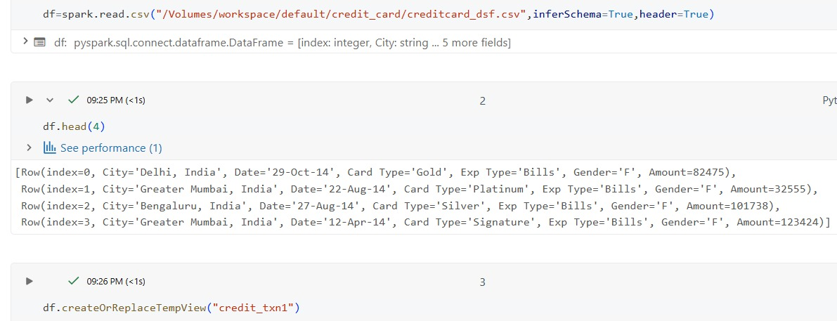

Scenarios using SparkSQL
- Write a query to calculate the total transaction amount spent in each city, then identify the top 5 cities with the highest total spending.
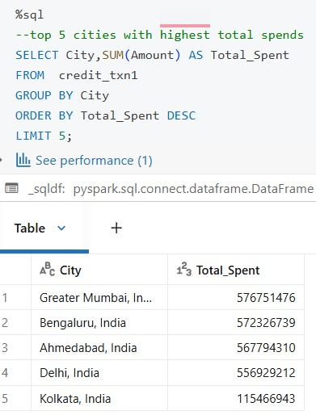

OUTPUT

2.Write a query to find the month with the highest total spending for each credit card type .

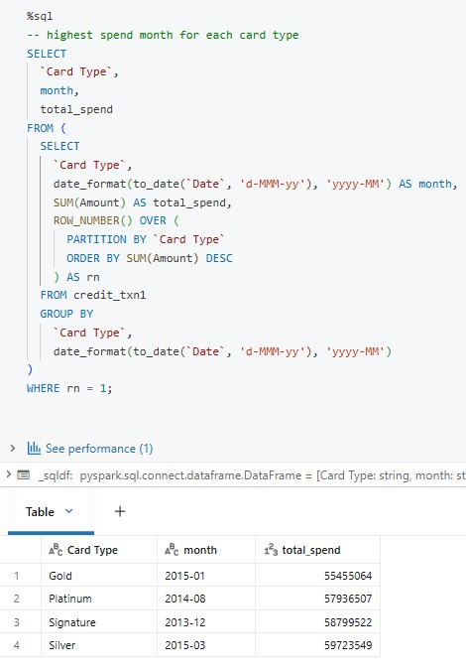

OUTPUT

3.Write a query to calculate the month-wise total credit card spending .The result should display the month(YYYY-MM) and the total amount spent, ordered by month.

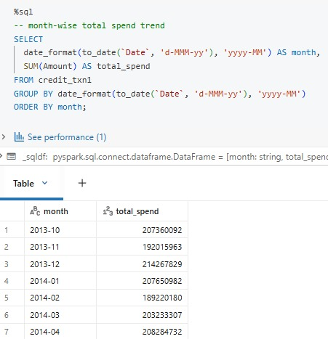

4. Write a query to print the transaction details(all columns from the table) for each card type when-- it reaches a cumulative of 100000 total spends.

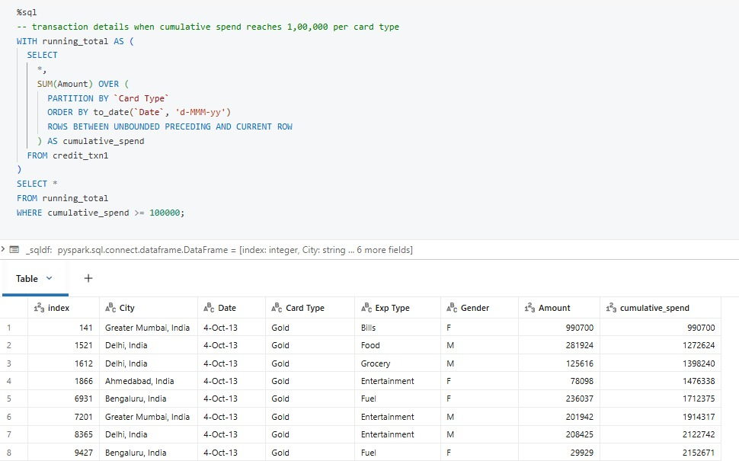

OUTPUT

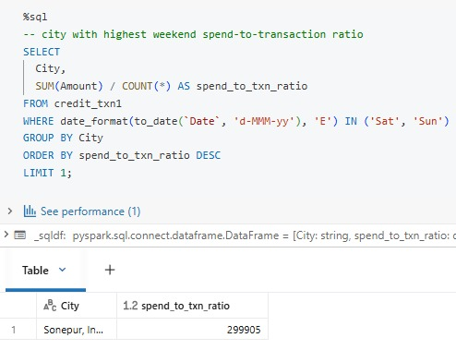
5. During weekends which city has highest total spend to total no of transactions ratio.

OUTPUT
6.write a query to find highest spending expense type for each city with its highest spend amount.
